**RDS Hands-on**

**Creating RDS service**

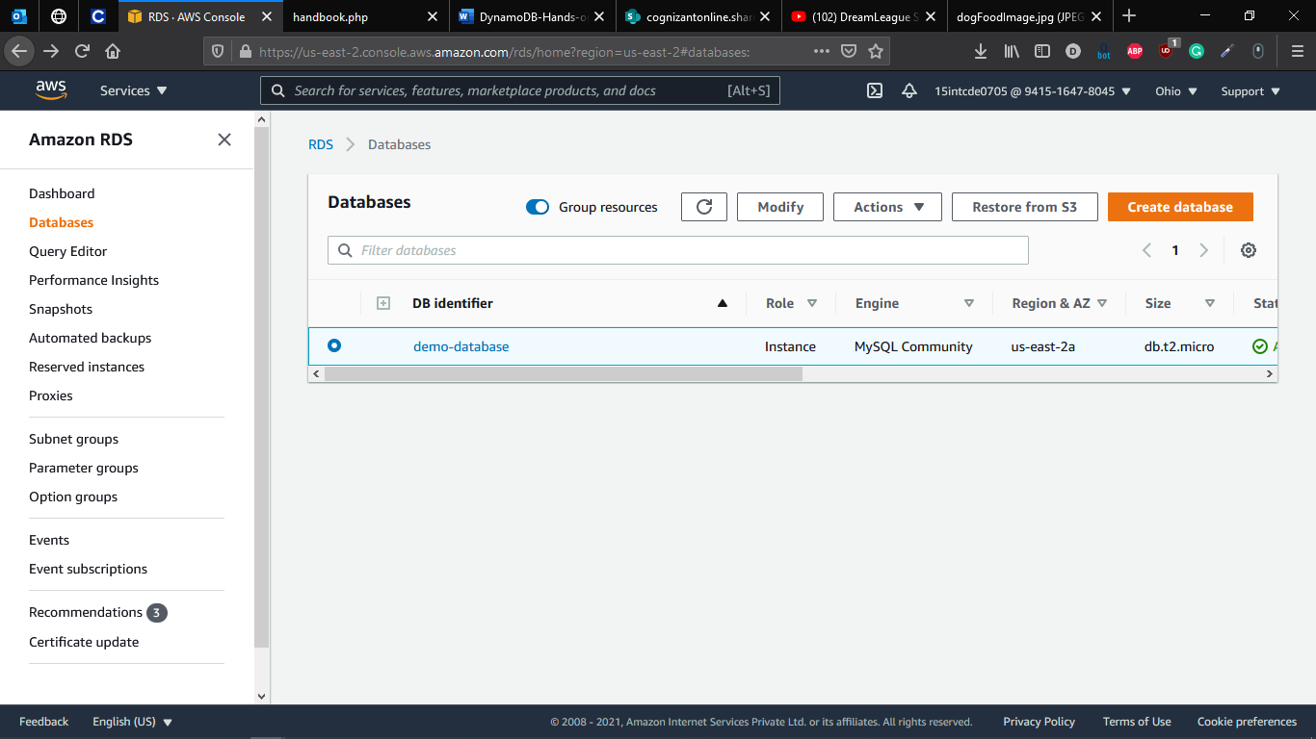

**Creation of RDS Service**

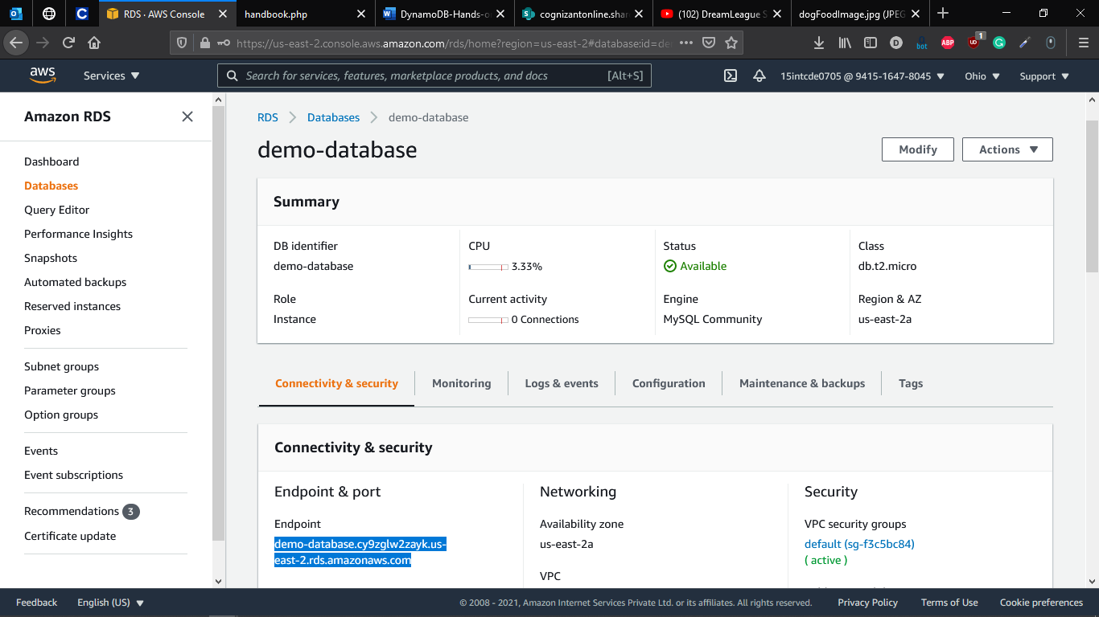

**Adding MYSQL inbound rule to database**

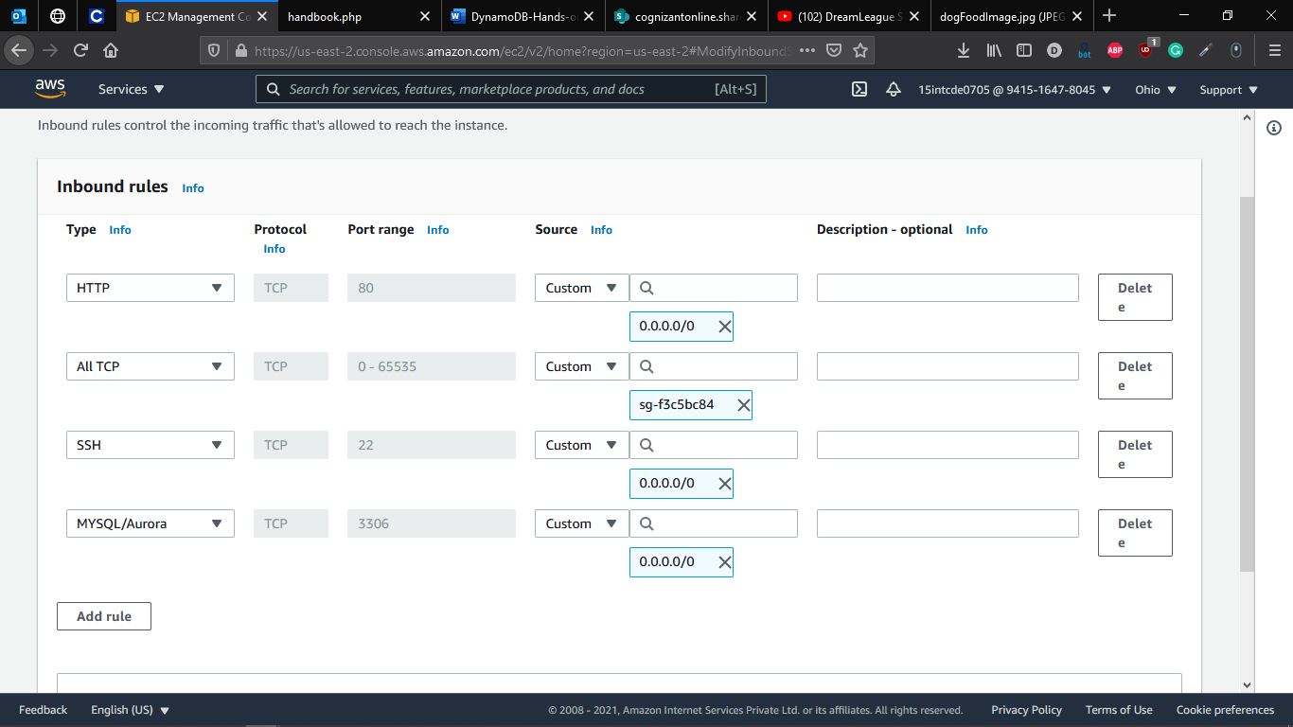

**Adding Connection to MySQL workbench**

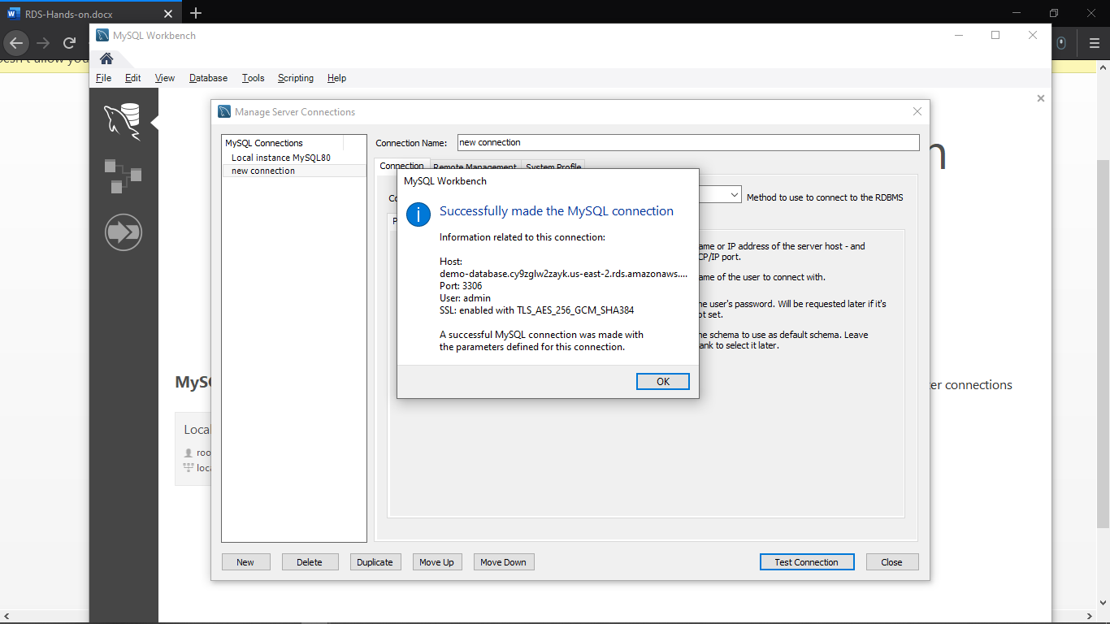

**Checking for the Database present in the RDS**

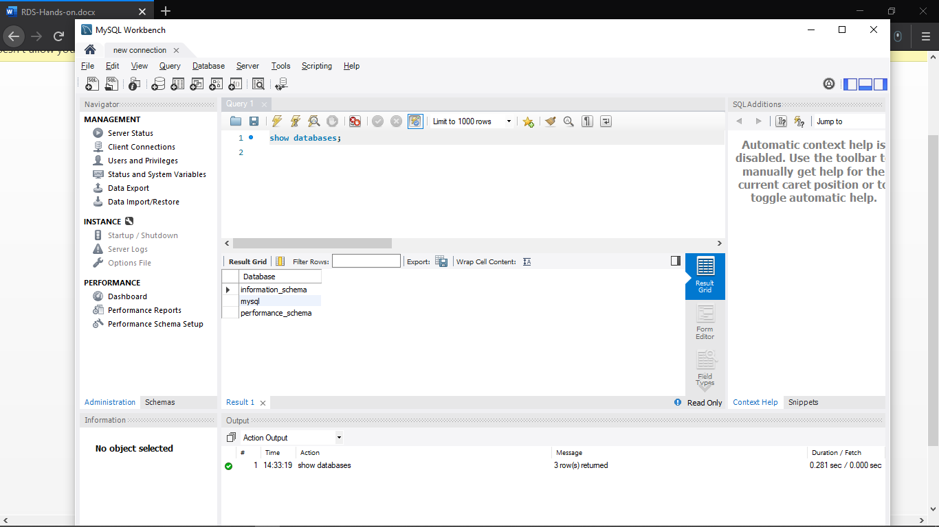

**Deleting the Database**

